Installation Sofa-Creator
Requirements:
The application requires Windows 10 Version 1903 (May 2019 Update).
The user account for the installation has to have administrative permissions.
Security settings have to allow sideloading of apps. You can enable this in the Windows Settings -> Update & Security -> For Developers.
To install the Creator, a certificate has to be installed in order to install the app. This is a temporary measure until we release the app with an official certificate.
- Download the installation package from: https://software.eosce.ch/sofa/Sofa-Creator-Alpha-0.7.0.0.zip
- Extract the zip file to a location of your choosing.
- Double click the certificate and choose "Install Certificate". (A popup might appear to ask you for permissions to install the certificate)
- In the following "Certificate Import Wizard" choose "Local Machine" and then "Next"
- In the next screen, choose "Place all certificates in the following store" and click "Browse"
- Choose "Trusted Root Certificates Authorities" and confirm both screens.
- Hit "Finish" on the lastscreen. (A security warning might show; confirm with "Yes")
- After these steps,the installbundle can be executed to install the Creator
Sofa-Evaluator
The Evaluator can be installed through TestFilght and requires iOS 12.
You will need to provide us with an e-mail address, we can send an invite and access code to. Please be advised, that the invite code is time restricted.

Overview
The Creator is split into several sections, these are shown as icons or as icons and text depending on the screen size.
To create a new project please follow the sequence shown in the chapter Usage below this chapter.
Prepare: To create and modify content (Forms, Candidates, Examiners)
Plan: Allows to define a schedule for the exam (at the moment only flex schedule is implemented).
Generate: When all the data and schedule is prepared, an exam package can be created. Distribute & Observe: Connected Evaluator devices can be observed on the assigned exam.
Settings: All project related settings (e.g. credentials) can be managed here.
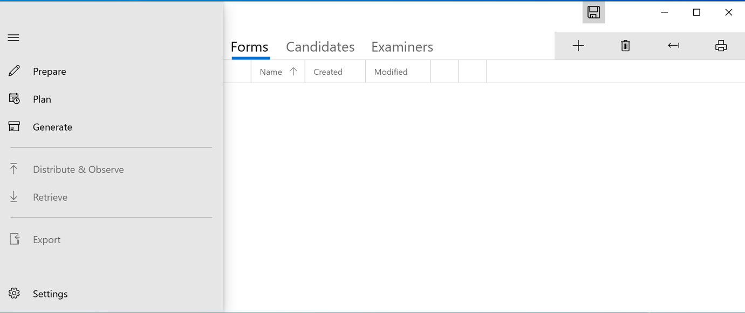

Usage
Settings
Different settings can be made for an exam project.
Tab General:
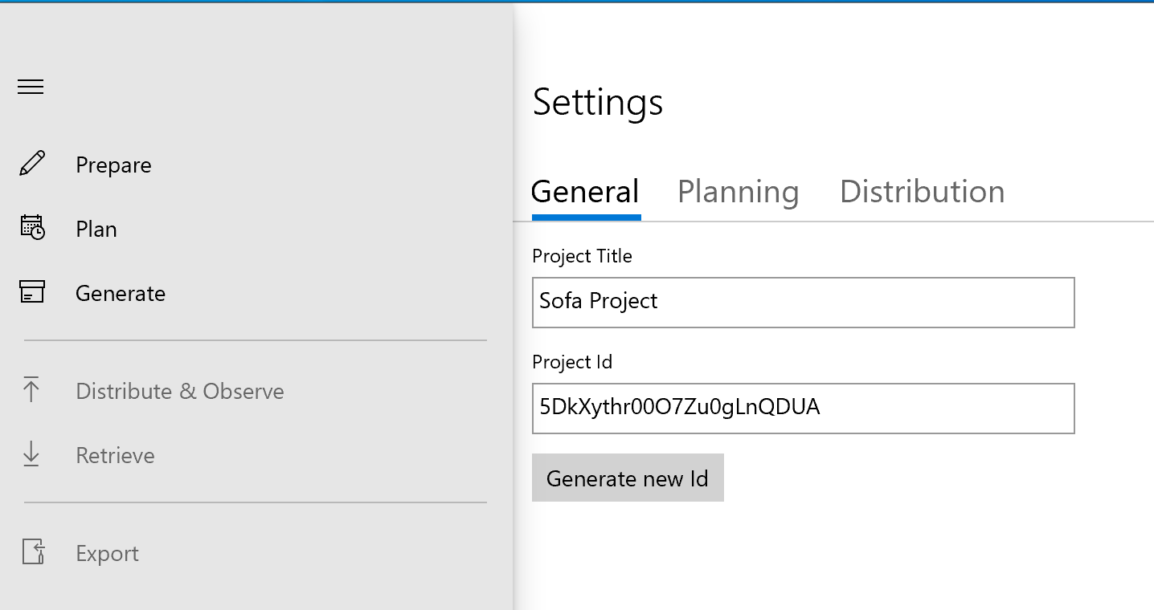
Fill out the Project Title, the Project ID Field is automatically generated.
Tab Planning
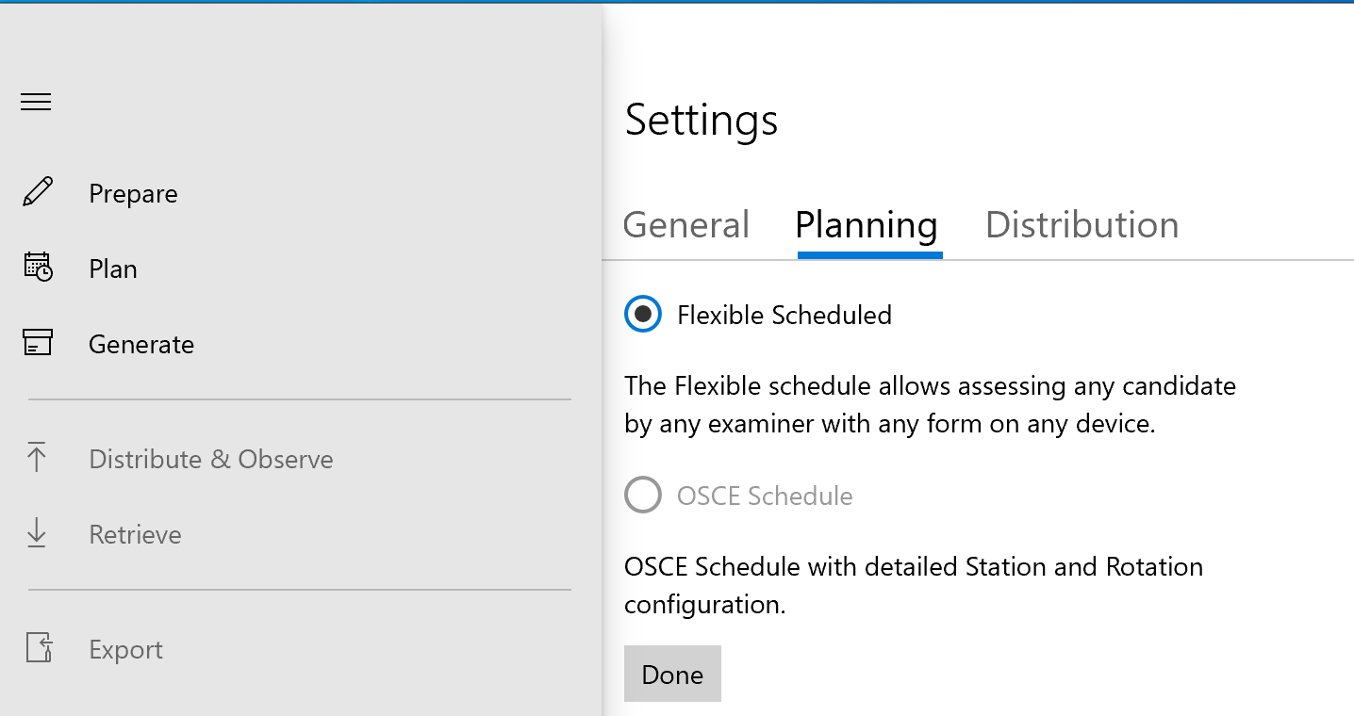Currently only Flexible Schedule is available, OSCE Schedule is planned for a later release.
This means, that all Forms, Candidates and Examiners are available on all connected evaluation devices.
Tab Distribution
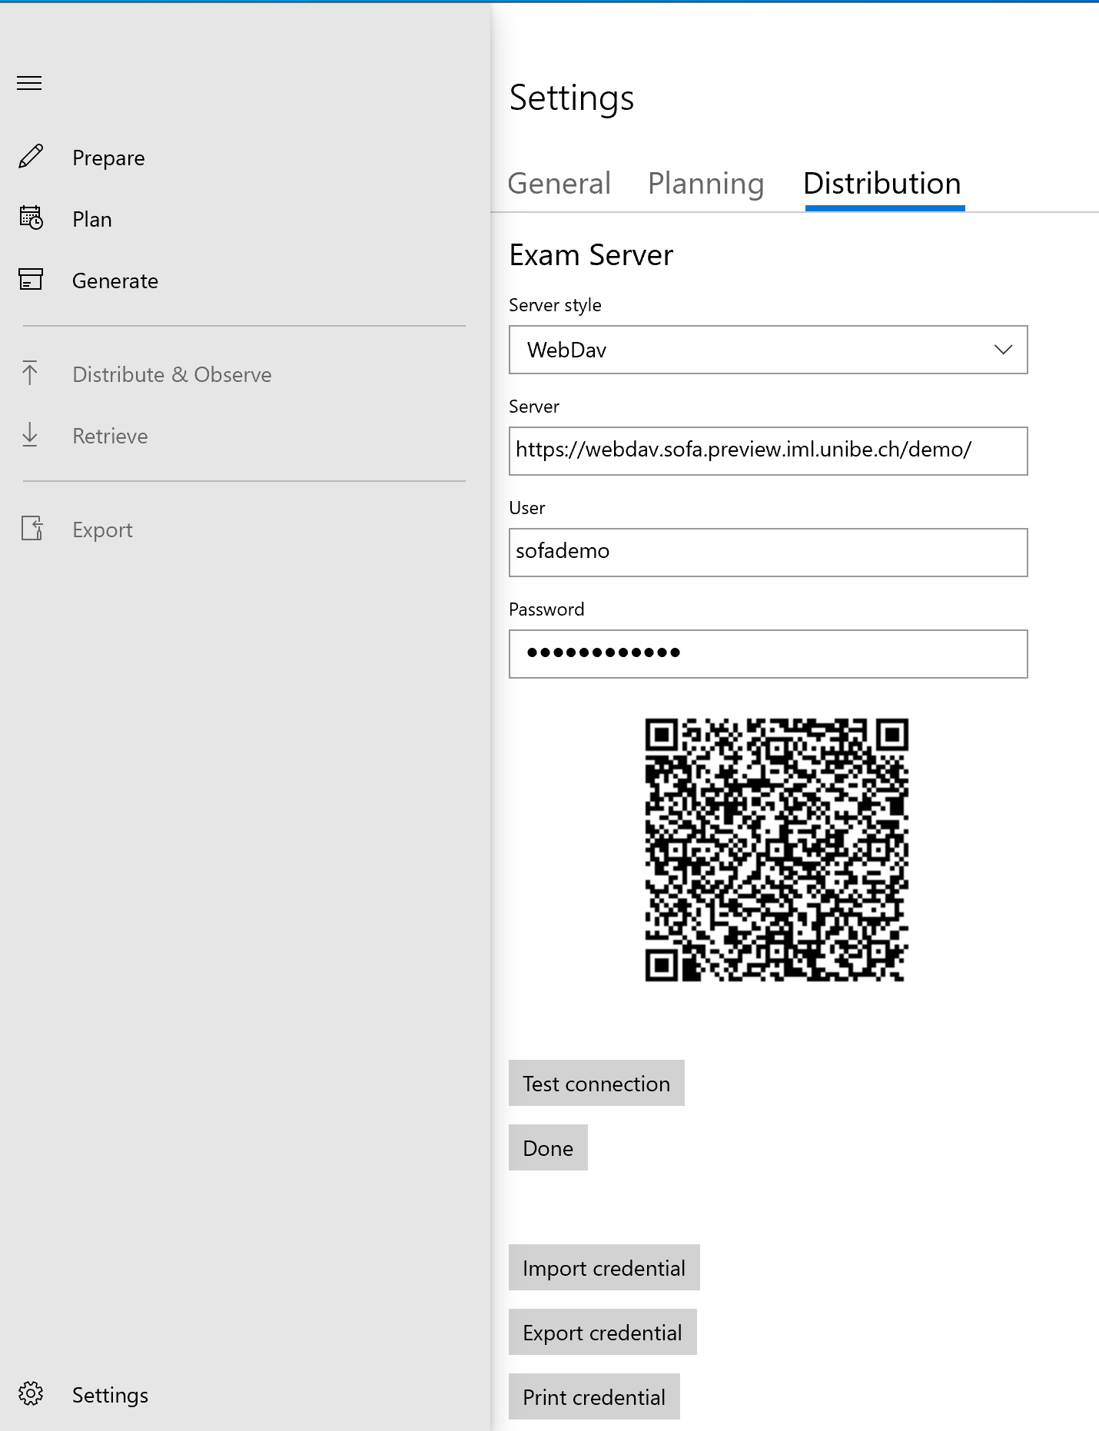
The most important is the credentials for an exam server. The credentials are displayed as a QR-Code which can be scanned by a Sofa-Evaluator, to connect to the server.
For Sofa we are planning to move away from AWS and use an easy to manage WebDAV Server, that can be deployed centrally or on premise.
You can Test the connection, and import or export the credentials.

Prepare
Generic Functions:
+ Button: Add a new Item (Form, Candidate, Examiner, depending on the tab you are in)
Trash: Delete selected Item(s)
Arrow: Open saved OSCE checklist or CSV (for Candidates or Examiner tab)
Printer: Print selected Items (QR Codes for Candidates or Examiner)
- Printing of QR-Code of the selected elements.
- Adding a new element(e.g. new form).
- Showing details of the selected form.
Tab Form
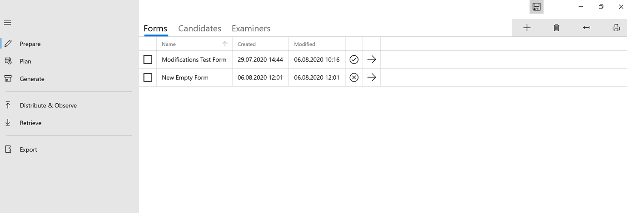
Here you can Create a new Form/Questionnaire by pressing the + Button
You can select and print or delete existing forms.
The 5th column shows the current Status of the form and it’s validity.
With the arrow in the 6th column you move to the edit function for the specific form.
Editing Forms
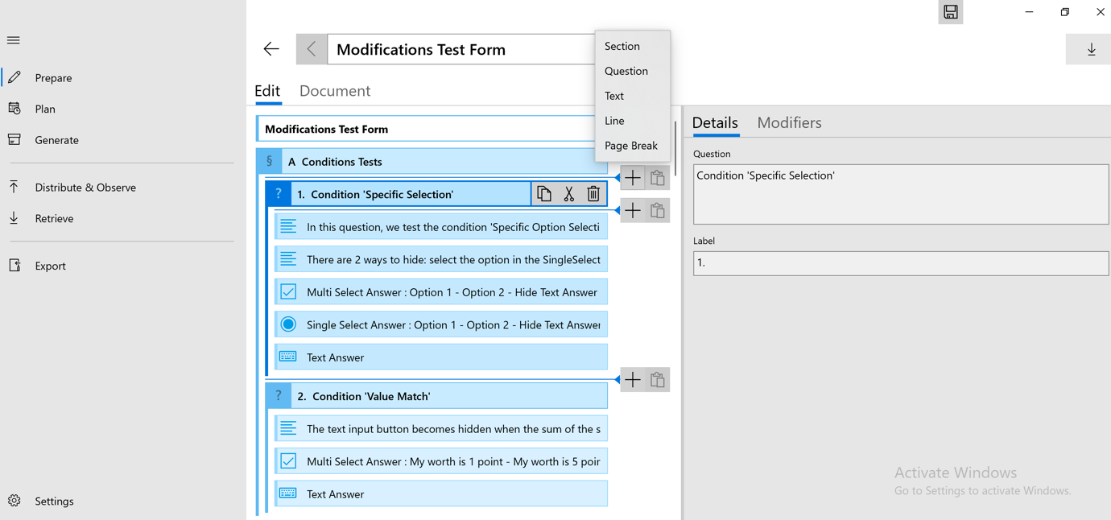
Here you see the Form structure in the left hand pane, the editing is done in the right hand pane.
Use the + Button to add one of the following options:
- Section: A section alows to group elements.
- Question: Defines the question elements (it is not of a specific type).
- Answer: This element defines what answer options a user can give to the surrounding question element.
- Text: A text block providing different visual style.
You can also copy, paste or delete Items or sections with the available buttons.
In addition, you are able to set visibility modifiers for certain Items, by switching to the Modifiers Tab in the right hand pane.
This is to allow to show and hide optional input for text fields, depending on the choosen answer.
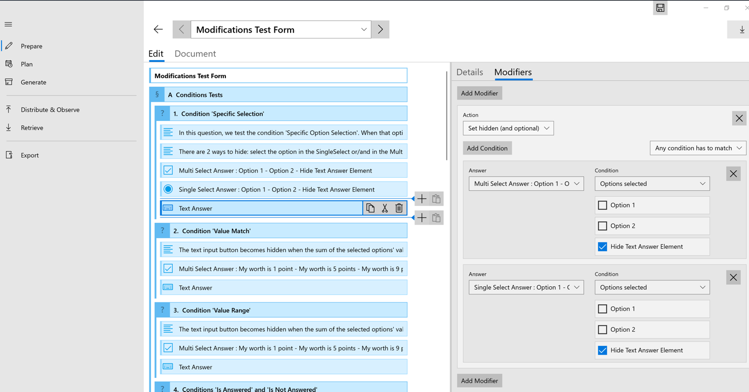
Tab Candidate
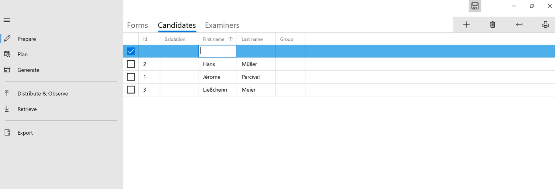
Here you can add or edit Candidates or import a CSV. The fields ID, First Name and Last Name need to be filled.
Tab Examiners
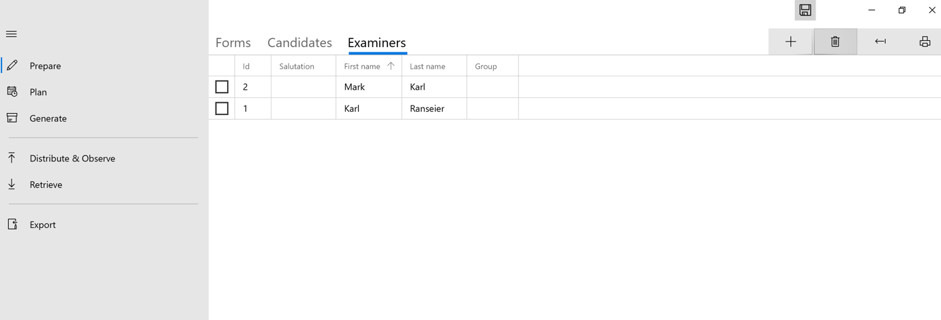Here you can add or edit Examiners or import a CSV. The fields ID, First Name and Last Name need to be filled
Plan
This Function is not yet available, as only flexible schedule is used.
Generate
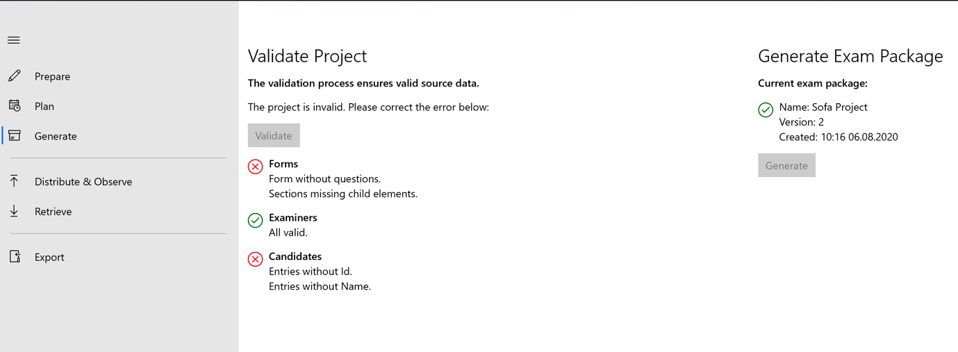For an exam to be distributed to devices, an exam package has to be created. Additionally the exam is validated and gives hints about needed fixes.
Once all Items in the Project are valid, you can generate the exam package and it will be pushed to the Server.
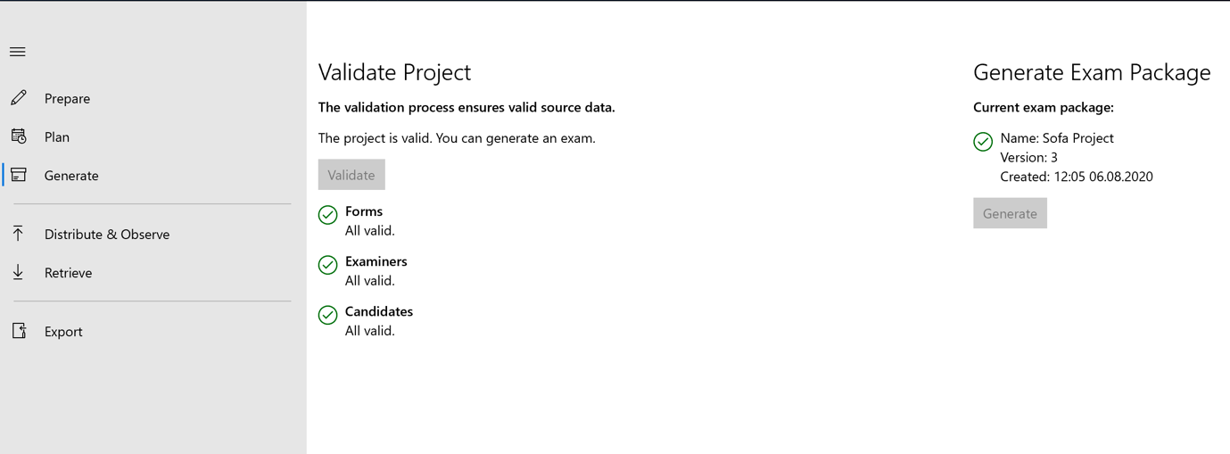
Distribute & Observe
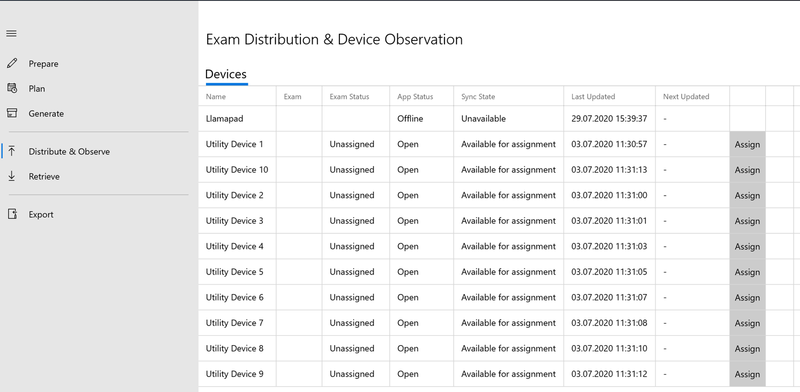This page will show all the devices connected to the server.
With the click of the distribute button the exam information is placed on the server for the device, which in turn will be read by the device when it synchronizes the next time.

Device Configuration
Even though the possible action for a device are displayed on the main screen, a settings screen (button top right corner) allows for more detaild information and actions for the application configuration.

Assessment
When a device has received an exam, it will show a screen allowing the selection of the form, examiner and candidate. The entries can be manually selected/serached or get scanned using the printed QR-Codes.
As soon as all required information is given, the assessment can start by tapping the coresponding button.

Retrieve
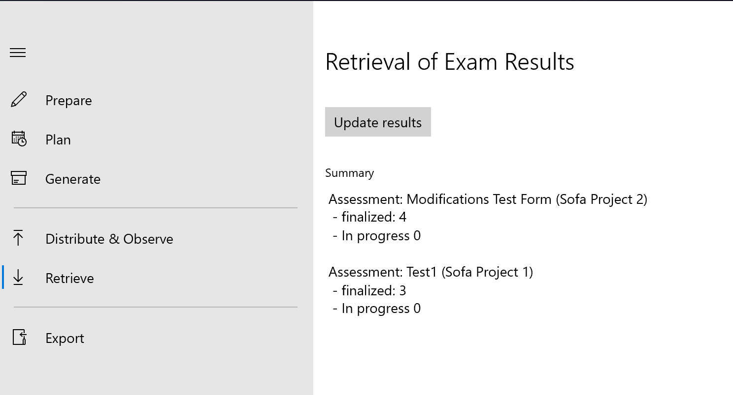As the assessment is finalized all Data is stored on the server and can be retrieved by the Sofa creator by pressing the Update results button.

Export
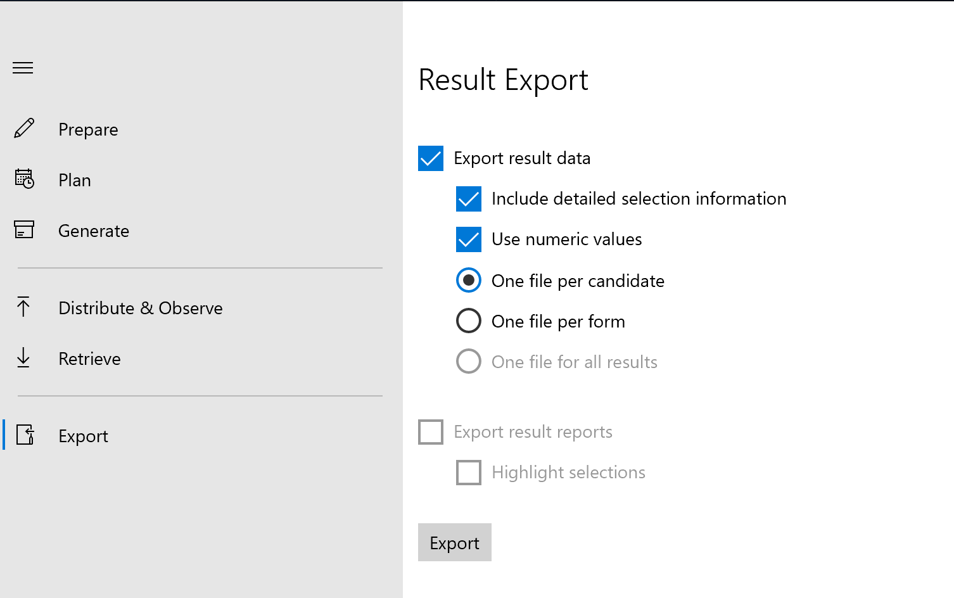
The results of the exam can be exported as a CSV file after retrieval.

